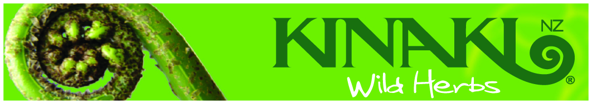

Service Agreement

For

Kinaki Maori food tours & guiding services


Submitted by
Charles P.T Royal
Roera 2004 Ltd
Trading as Kinaki NZ
P.O Box 1030
Rotorua 3010

Ph / fax 0064 7 3453122 e mail kinaki@xtra.co.nz

www.maorifood.com

Introduction.
This contract is offered in the interests of offering Maori food tours & guiding services to
name of guests.

The contracted activity presented in this proposal is developed in response to a request to provide such services by name of guests on date of request.

The Maori food tour and guiding service will be conducted on date at venue for a duration of
No. hours/days

Kinaki NZ Consultants offer the following services:

Maori food & guiding services
Key elements
- Planning and preparation of Maori food tour & guiding services with appropriate Maori food & content.
- Delivery of Maori food tour & guiding services.

Contract period and payment rate.

The contract period will be ___ hours/days from __________ to __________ at a rate of ____ per hour / _____ per day.

Payment schedule.
50% deposit on booking confirmation.
50% remainder on completion of tour.

Cancellation fee

50% cancellation fee of deposit if contracting party cancels after confirmation of booking.

Heoi ano e te rangatira,
Nga mihi nui ki a koe,

Charles P.T Royal

P.O Box 1030

Rotorua 3010

Aotearoa New Zealand.

Ph/ fax 0064 7 3453122

E mail kinaki@xtra.co.nz

www.maorifood.com

Please indicate your acceptance of this Contract as a Contracted Arrangement by signing and dating below.

Contracting Party agrees to contract Charles P.T Royal Managing Director of Kinaki NZ as per the terms stated in this Contract Proposal.

____________________________ ____________________________

for: Contractor for: Charles P.T Royal
Managing Director
Kinaki NZ

Date: __________ Date: __________

If happy please sign & fax to 0064 7 3453122.

Deposit can be paid on confirmation of booking.

More informatiom e mail Charles at kinaki@xtra.co.nz

